PostgreSQL have a client-server architecture:
- Server: DBMS itself, installed in the pc and run in background
- Multiple clients can connect to the server: other application

To have access on the server each client need a credential (usually is username and password configured on the server)

postgres have a default username called postgres and let the user choose the password

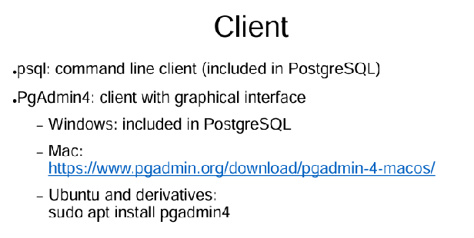
different clients

default client:
- psql, is a tool that you execute over the terminal
- pgadmin4: other client identical to psql but good looking interface

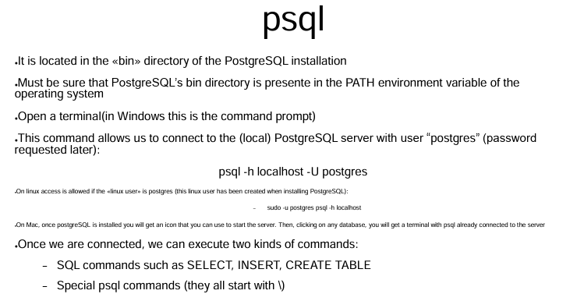
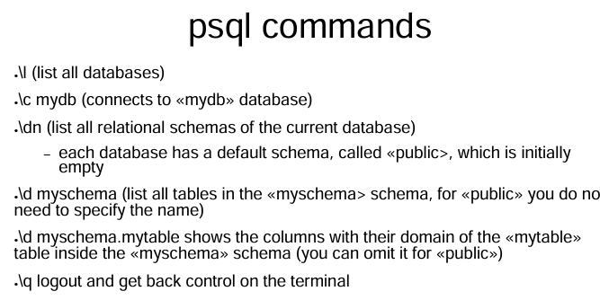

HOW TO OPEN ON MY PC
- Open CMD
- Go to
- C:\Program Files\PostgreSQL\16
- Left-click on the folder called “bin”
- Run terminal there
- Write “psql -ħ/2 localhost -U postgres”
- Insert password (postgres)

\l ⟹ list all the database in the server

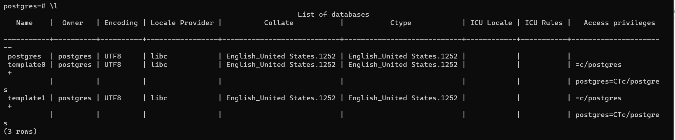
Show the owner, and other information. THere are default database (postgres, template0, template1)

CREATE/DELETE DATABASE
To create a database use CREATE DATABASE command, ALL SQL COMMANDS FINISH WITH ;

To delete a database use DROP DATABASE command,

CREATE TABLE INSIDE A DATABSE
Connect to the database first with \c emplyeedb;

Then \dn to see all the relationship

Postgres organizes the database in a schema.
There is always a default schema that collect every schema (this schema is called public)

Use CREATE TABLE employee; to specify the name of the table

With \d now you will see that you have one table called employees
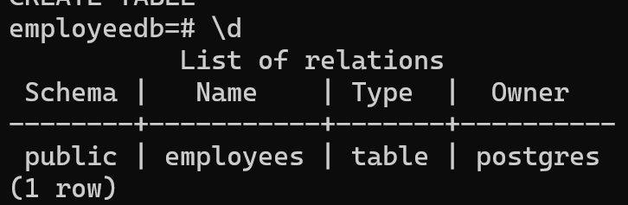

NOTE: if you use \d employees; it will see the table. The constraint in the id is that is not null, because the id is the primary key. Everything else can be null
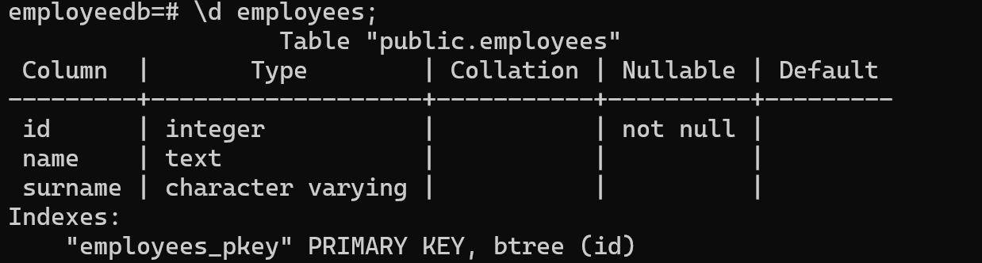

Use \q to go back from the table to the server

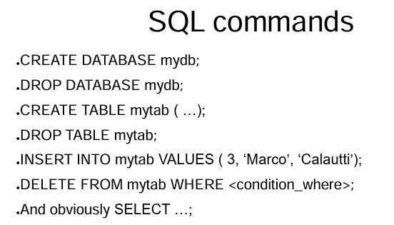

open PGADMIN → Serves (right-click) → register server

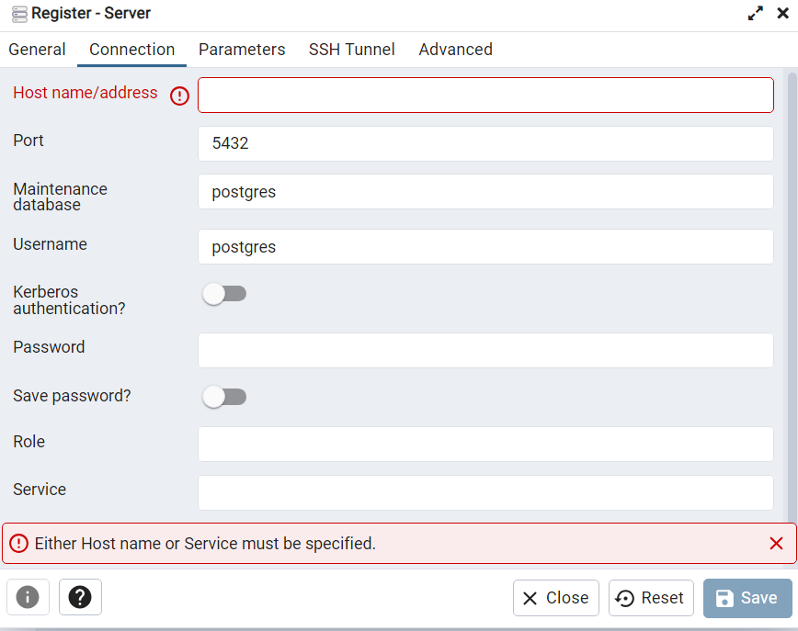
Specify on the connection page localhost and port 5432

Then specify the password

When I create it
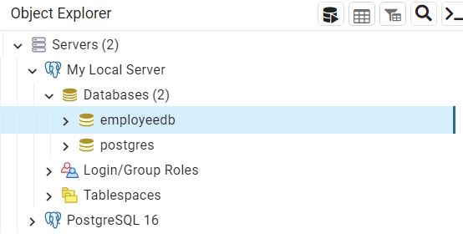
I can see the database I created before

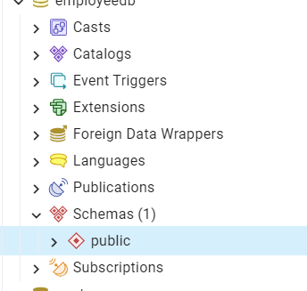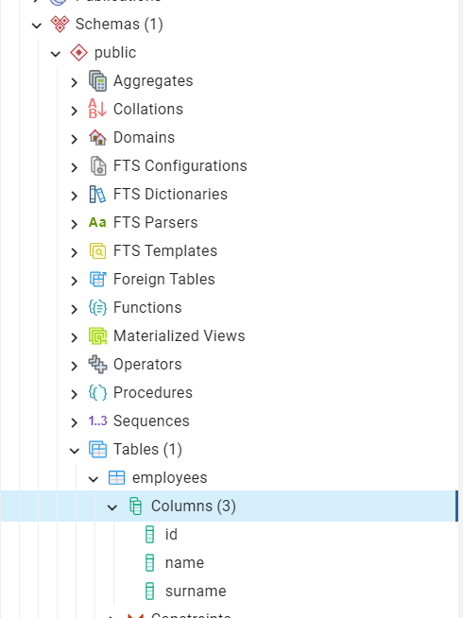
We can see the table with the columns that we created

To have a small summary of a table press on the table (right click) → go to properties → go to columns
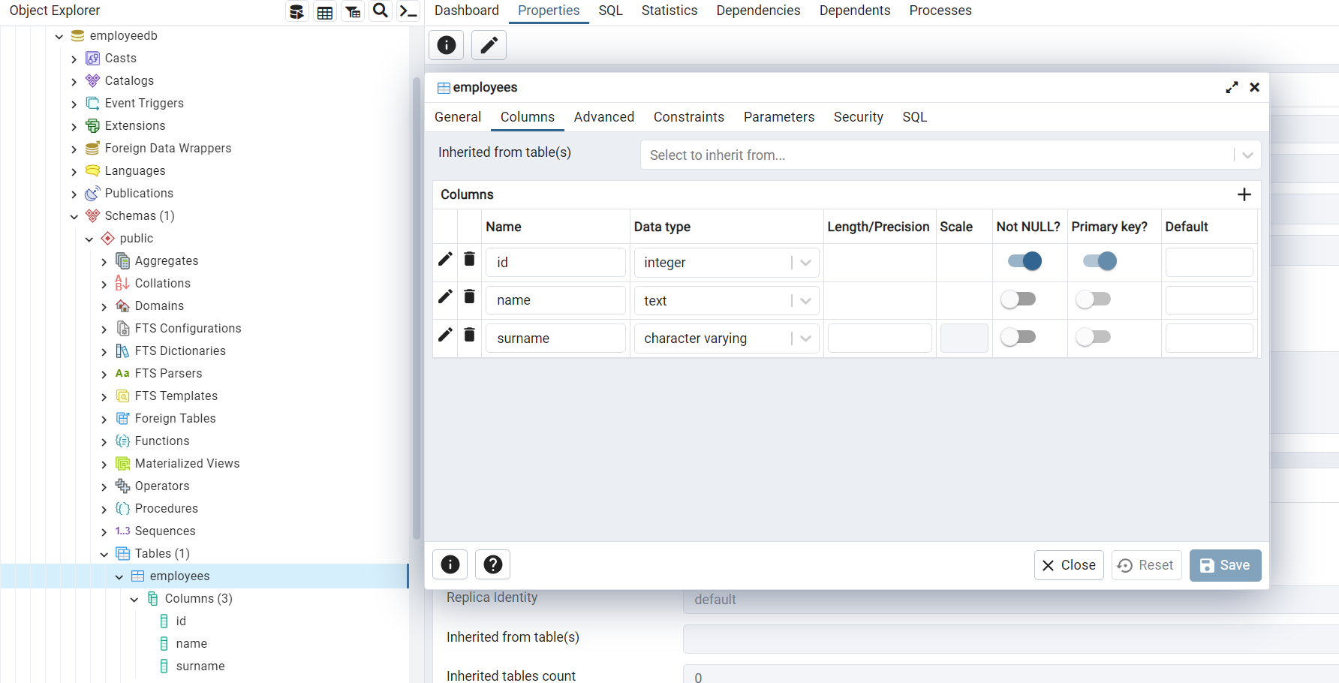

How to execute SQL commands?
When you open the databse go to tools (top menu) and press query tool
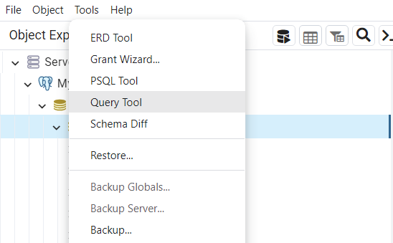

Then you can write commands and run it

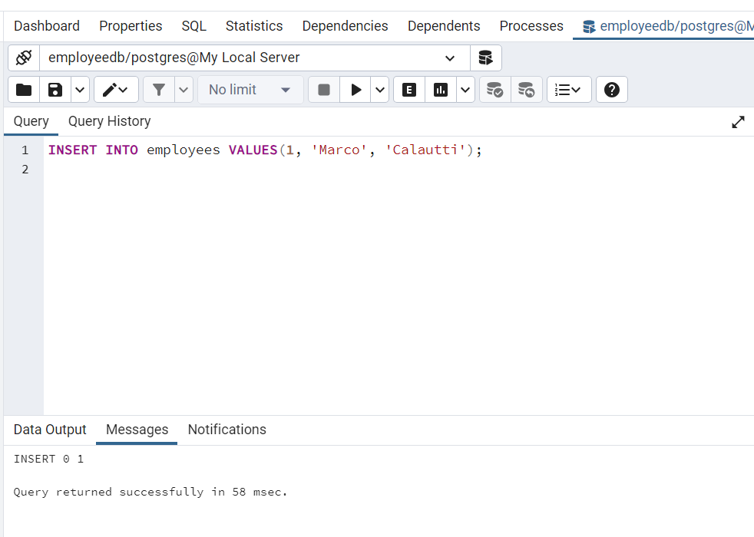

To view the data you can do:
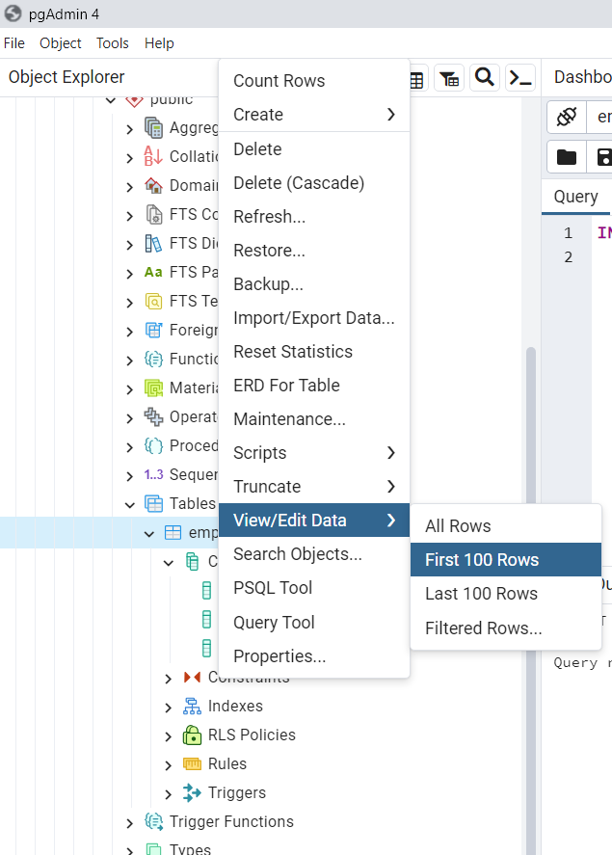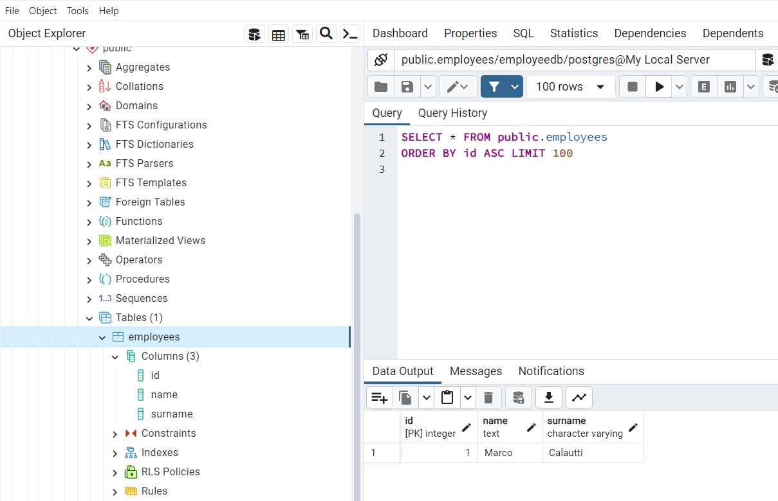

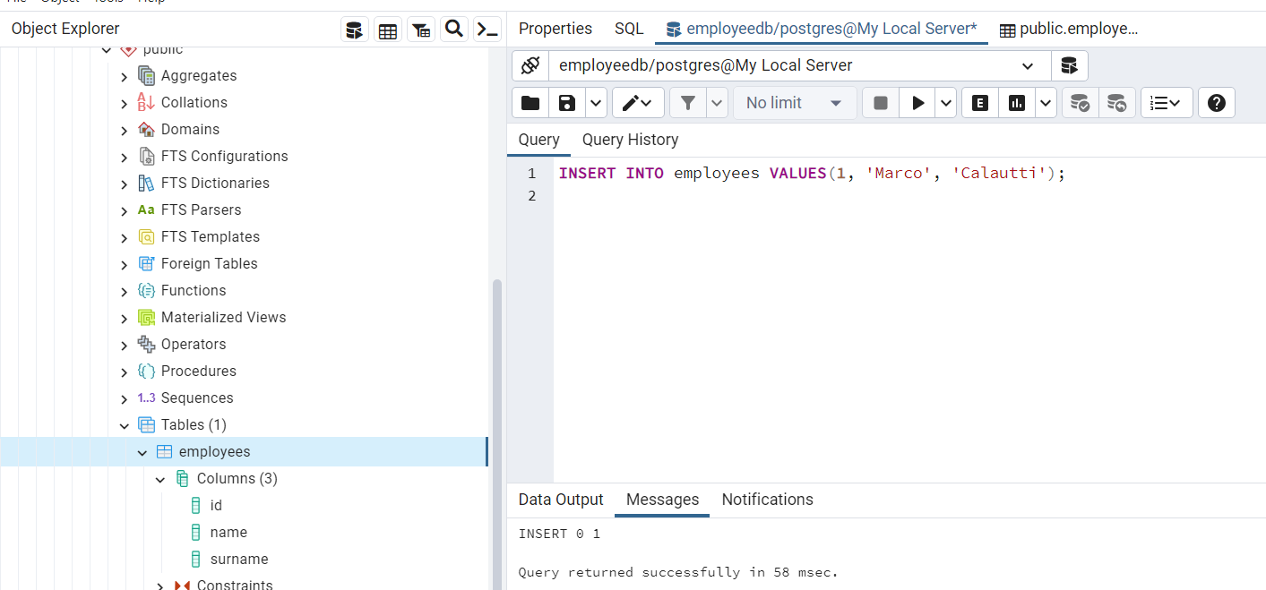NOTE: you can switch faster by using and personalizing the menu on top

Also if I do
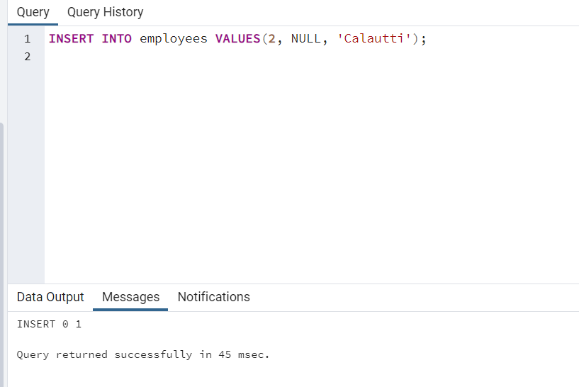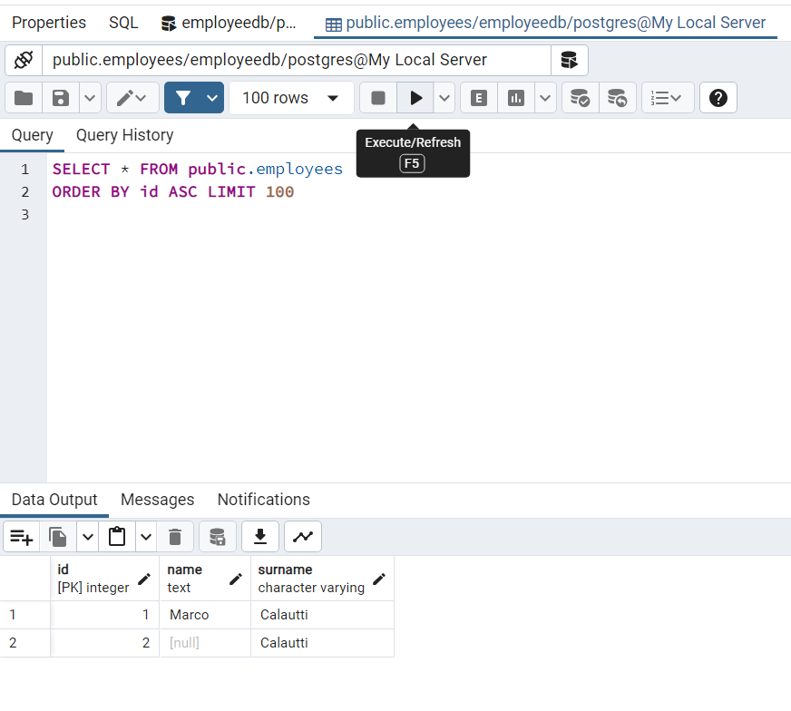
… I can go back to the table and employee table and run a query and I will see the new row

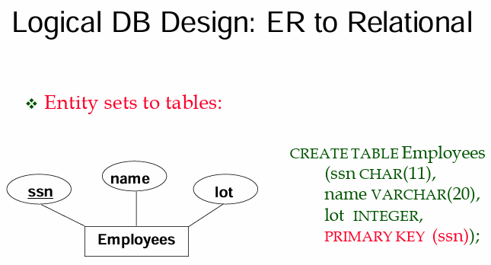

In a diagram we will have a relational entity set (employees have a snn, name, (parking) lot)

MAPPING NO CONSTRAINT
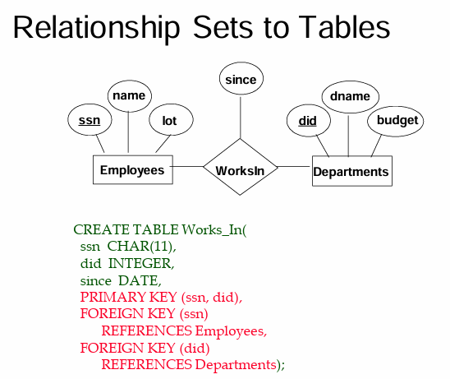
Convert relationship

Employee and departments are converted as usual with the command CREATE TABLE

As an example Departments would be
CREATE TABLE Departmenets(did INTEGER, dname TEXT, budgmet INTEGER, PRIMARY KEY(did));

We will summarize the two relation as:
- departments(did, dname, budget)
- employees(ssn, name, lot)

We want to build the relation WorksIn the trick is to map it as a relation. The relation should be named Works_in with primary key (ssn and did). We can also specify the attribute of worksIn (such as since). ⟹ works_in(ssn, did, since)

NOTE: this is too liberal because I could have Marco, IT, 1/1/2000 and also Marco, IT 3/12/2004. This is too liberal and we want to prevent it. ⟹ The primary key of the works_in relation should be the combination of the ssn of the employees and the did of the department.

Now we can avoid having a relationship twice with two different times. By using REFERENCES we know that the ssn must be from the employees relation and not a random string from somewhere else, same for the department. We force that key to come from specific tables.

NOTE NOTE: the ssn and did can not be NULL, but the data (since) could be NULL (but it should be NOT NULL) in most cases.

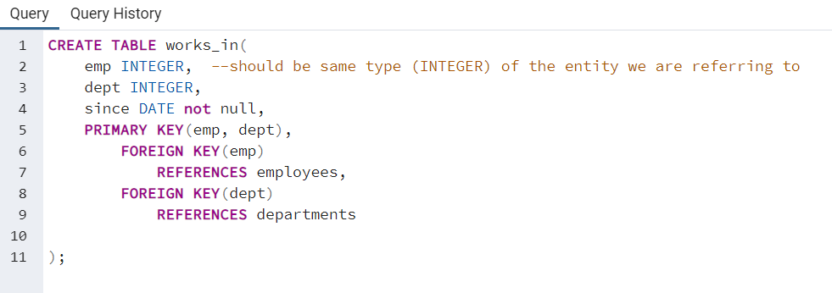
NOTE: use GENERATED ALWAYS AS IDENTITY so that the new value of ssn is produced by the pc, this works only when the ID has no meaning, it is not good for tax code for example.

NOT NULL so that the name should not be null.

NOTE: since we specified GENERATED ALWAYS AS IDENTITY for the ssn we can not insert anymore
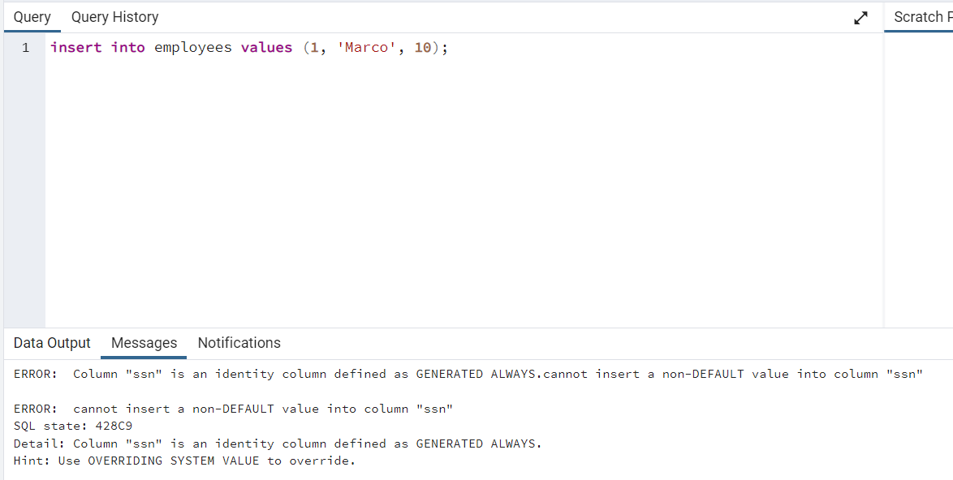
⟹ to fix this we can switch to GENERATED BY DEFAULT AS IDENTITY then we can specify the ssn

When one columns is generated {by default|always} as identity we can specify one element less in the values but we should specify the columns with employees(ename, lot) otherwise ‘Marco’ and 10 are not sure to which column they should go
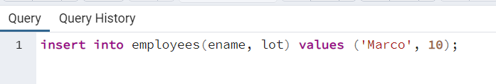

INSERT ELEMENTS IN WORKS_IN
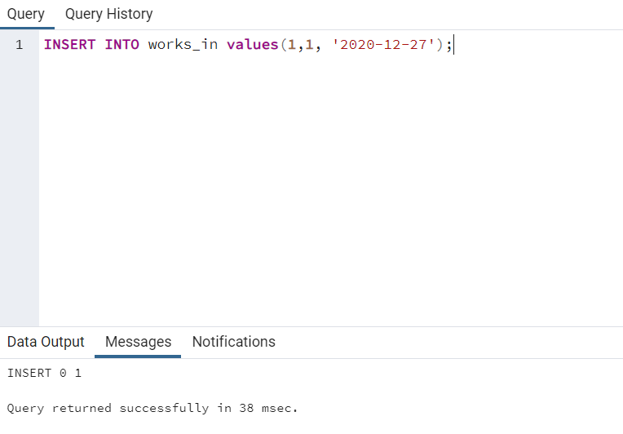
There must be an ssn of values 1 for employees and a did value 1 for departments, otherwise it will give an error.

MAPPING AT MOST ONE

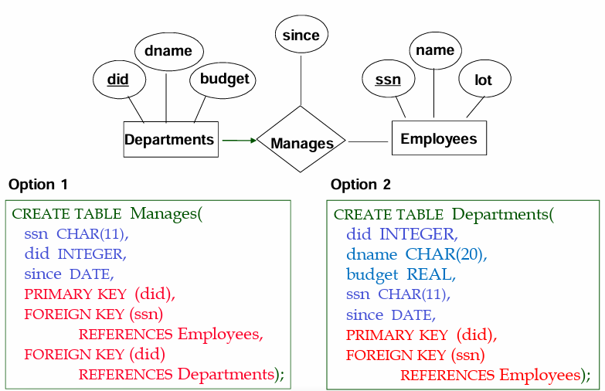

Here we have some constraints. Here we say that each department can have at most one employee that manages the department. How do we do it?

Option1: the only change we need to do to have each department can have at most one employee as manager is to remove the ssn from the primary key. In this way we have the relation manage based only of the key did that can not be repeated ⟹ so we have at most one.

But an employee can be the manager of one, three or none departments.

Option2:
We do not have at all the table manages and since a department must have at most one manager we add an attribute referring to the id of the employee. Also we add a foreign key for the ssn of the employee (so that the manager must be an employee). If we don’t know the manger we can have NOT NULL.

⟹ the advantage is that we can check easily if the employee have or not a manager.

MAPPING EXACTLY ONE
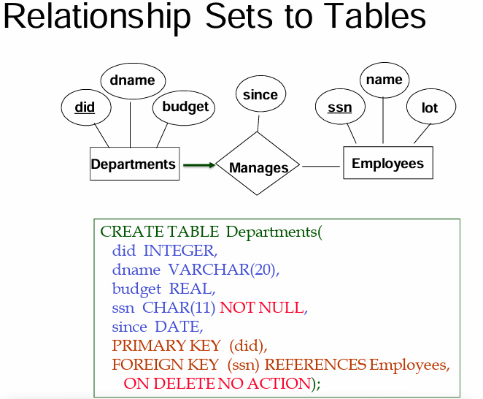

Every department should be managed by exactly one employee.
We add the column of the manager and this column should not be null. ⟹ so every department must have an employee as manager. Also we can add (not mandatory) ON DELETE NO ACTION to specify what to do when we delete the manager.

MAPPING AT LEAST ONE

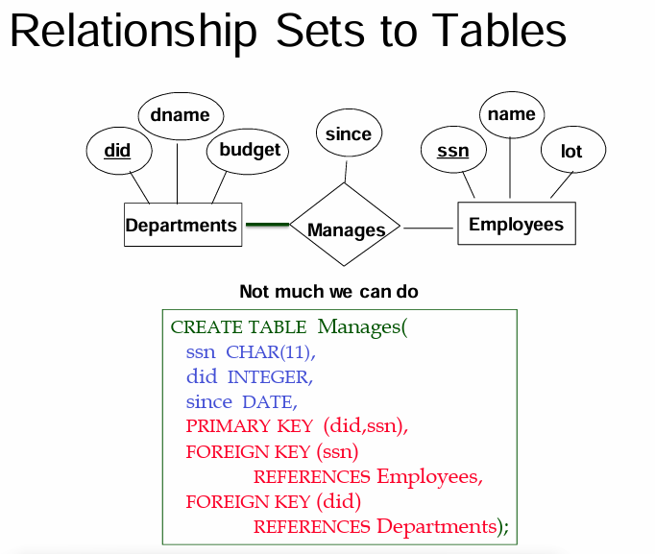

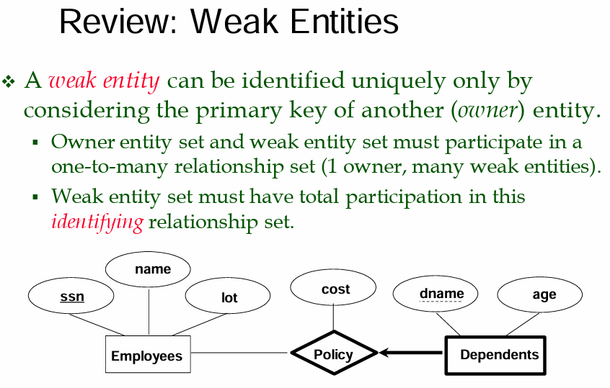

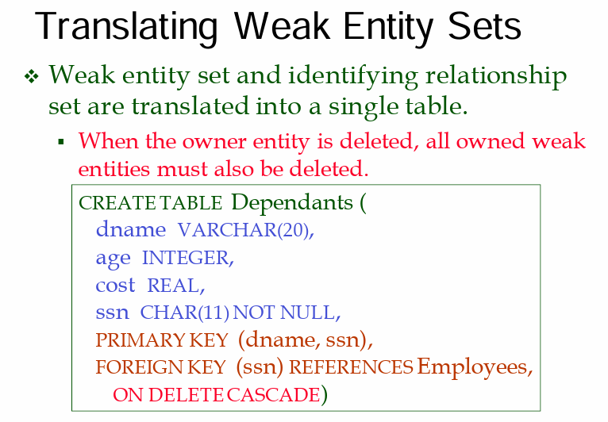Person that wants an insurance policy from somebody (slide before). We can uniquely identify the person by its name

We identity the person by the policy

the primary key is the combination of the dname and ssn.
Also it can not exactly without a supporting entity, and so if one entity is removed we have to remove the weak ⟹ so use ON DELETE CASCADE

